 | 26.9 Editors - Properties Editor - Modifiers Properties Tab
Table of content
25.8 Editors - Properties Editor - Modifiers Tab 1
Object types with modifiers 2
Modifier types 2
Geometry Nodes 3
Modify 3
Generate 3
Deform 3
Simulate 3
Color 3
Hair 3
General functionality 4
Add Modifier 4
Header elements 4
Collapse panel 4
Modifier Icon 4
Modifier Name 5
On Cage 5
Edit Mode 5
Realtime 5
Render 5
Header menu 5
Apply as Shapekey 5
Save as Shapekey 5
Duplicate 5
Copy to Selected 5
Move to first 6
Move to last 6
Move to Nodes 6
Show Node Groups 6
Remove 6
Change Context 6
Reorder 6
Animate Property 6

25.8 Editors - Properties Editor - Modifiers Tab

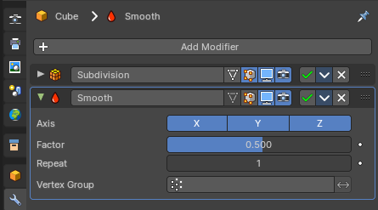
Modifers are automatic operations that affects the geometry of objects in a non destructive way. You can for example subdivide a mesh object. And the base geometry stays intact.
Modifiers can also be applied to the object. In this case the change is destructive.
Modifiers gets added in a so called modifier stack. Simply choose a modifier from the list. Modifiers can build on top of each other and can be reordered. Sometimes the order is important.

Object types with modifiers
There are two general types of objects where you can use modifiers. Mesh objects and Curve objects. The grease pencil object is a special object in this regards. And has some modifiers that the other object types does not have. But it is under the hood also a curve object.
Each of them shows a different set of modifiers. Some modifers have the same name, but shows different settings for different object types.
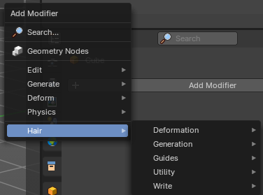
Mesh object

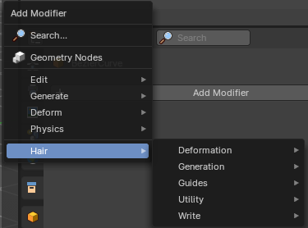
Curve + Text Object

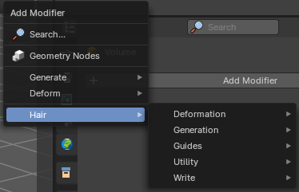
Volume Object

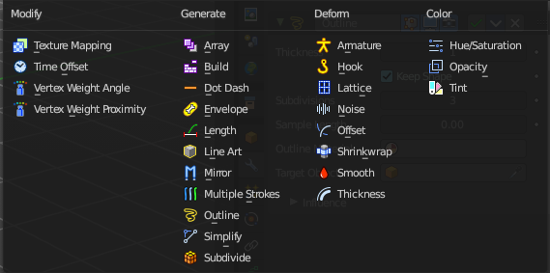
Grease Pencil Object

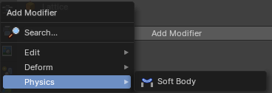
Lattice Object

Modifier types
There are several types of modifiers:

Geometry Nodes
This allows you to insert a Geometry Nodes modifier.

Modify
Change the shape of an object, without altering its topology. But not directly, but by some other data like vertex groups.

Generate
Constructive/destructive tools that will affect the whole Topology of the mesh. They can change the general appearance of the object, or add new geometry to it.

Deform
Change the shape of an object, without altering its topology.

Simulate
Those represent physics simulations. In most cases, they are automatically added to the modifiers stack whenever a Particle System or Physics simulation is enabled. Their only role is to define the position in the modifier stack from which is taken the base data for the simulation they represent. As such, they typically have no attributes, and are controlled by settings exposed in separate sections of the Properties.

Color
Just for the grease pencil object. Adds some modifiers to adjust the color.

Hair
Mesh Object. Add Hair Curve Modifiers.

General functionality

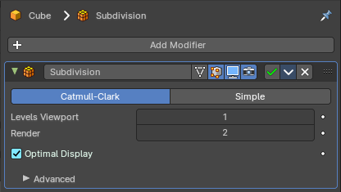
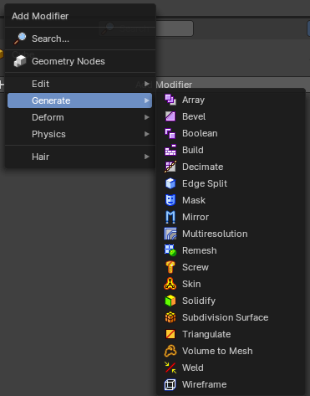
Add Modifier

To add a modifier to an object, simply open the add menu, and choose the type of modifier that you want to add.
This will add the modifier to the list.
For some modifiers you will also find menu items in the 3D view. The Quick effect Fluid will for example add a fluid and liquid particle system modifier.
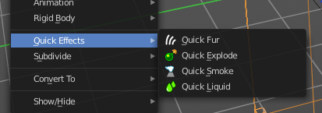
This menu entries exists to simplify the workflow. This menu entries are described in other chapters.

Header elements
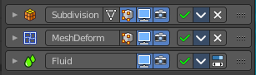
You might want to disable a modifier temporarily. Or just see the effect in the final rendering. This can be adjusted in the header. The header is what you see when you collapse the modifier panel.
Note that not all modifiers have the same header content. Fluid modifiers for example doesn't even have a remove button. They get removed by removing the fluid simulation in the physics tab.
Elements are explained from left to right.

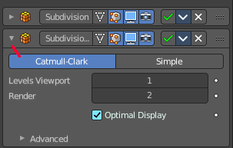
Collapse panel
The whole modifier panel can be collapsed. Click at the arrow button up left in the header.

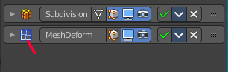
Modifier Icon
This icon shows the type of the modifier. And has no further functionality.

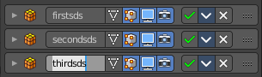
Modifier Name
The name of the modifier. You can rename modifiers by clicking into the edit field and change the text.

On Cage
Adjust edit cage to modifier result. With this option the geometry will be viewed at the position they will be after the modifier is calculated. Important for the mirror modifier for example.

Edit Mode
Display the modifier result in edit mode.

Realtime
Display the modifier in the viewport.

Render
Display the modifier in the rendered result.

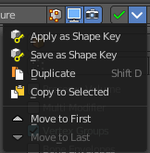
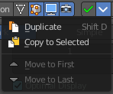
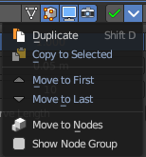
Header menu

Apply as Shapekey
Armature modifier. Applies the current pose as a shape key, and removes the modifier.

Save as Shapekey
Armature modifier. Applies the current pose as a shape key, and keeps the modifier.

Duplicate
Duplicates the modifier, and places the duplicate below the current modifier.

Copy to Selected
Copies the modifier to the selected object. First select the object where you want to paste the modifier to. Then select the object with the modifier with holding down shift so that both objects are selected. Now use Copy to Selected. And the modifier will copy over to the first object. Works also with multiple objects.

Move to first
Move the modifier to the first position in the stack.

Move to last
Move the modifier to the last position in the stack.

Move to Nodes
Hair modifier. Moves the modifier to nodes instead.

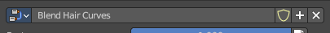
Show Node Groups
Hair modifier. Shows the node groups prop in the modifier

Remove
Removes the modifier from the stack.

Change Context
Some modifiers cannot be removed from the modifiers stack directly. Like fluid modifiers. You need to remove the fluid simulation instead, in the physics tab. With the change context button you jump to the required tab where you can now remove the simulation.

Reorder
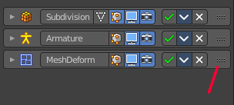
You can have more than one modifier in the list. And sometimes the order of the modifiers is very important.
Grab the handler at the right and drag the modifier to the position where you want it to have.

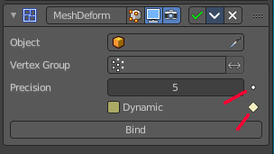
Animate Property
Some of the properties can be animated. Click at the animate property button at the right to add a keyframe.

